School of Vocational Education

Associate Degree in Information Technology AD006

INTE 2507 Virtualization Semester 1 2021 COVID-19

Make sure you place your name and student number of this documentation

**Student Name: Jack Sydenham Student Number: S3841816**

***Due date by the 19th of June by 23:59pm in Canvas***

Virtualization project 50% of your total grade Total Marks 85

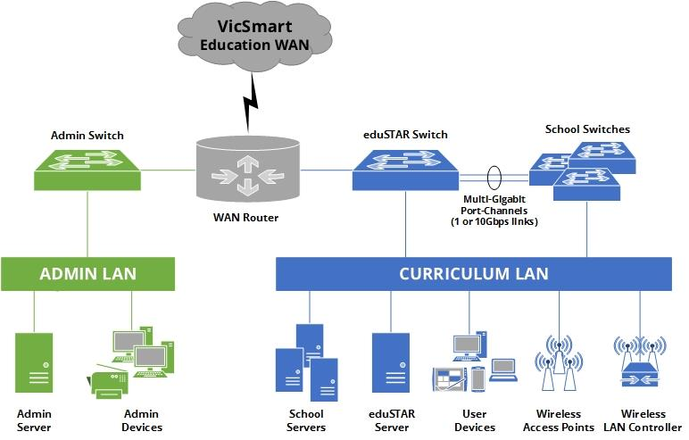

Example of typical current layout of Secondary college network infrastructure but not this one as shown in Figure 1.0

**General overview information about the school and equipment.**

We have a Secondary college in the Southern of Melbourne. It has currently 1600 students and over 150 plus staff work at the College. There is about 250 computers in the college. It is projected that the school will increase between 15% to 25% in the next Three to Five years due to more families moving in this area. The College is over 35 years old and has had some new building added to the school over the years as IT has been added as well over the years as well.

The College has been given permission by the Victorian government to expand its campus by adding new building and put in a new IT infrastructure into the school.

In Figure 1.0 is not the actual physical layout of the IT but similar but not the same.

As the COVID-19 in its 2nd year has hit the world wide the school was not prepared to be working online. As all schools in Victoria were rushing to go online this school had some difficulties for students to access remotely learning from the school.

The board of the College has been granted permission to bring in IT consultants to look at the school current infrastructure and see what improvement they can do to improve the online experience i.e future proof if we have another pandemic around the world. The IT consultants does not need to worry about the what IT infrastructure that the Victoria government uses. Your main responsibility is the inter IT how it has been setup in the College.

The information is what infrastructure the currently has been setup in the College ( school currently)

**Room Size ( location of Servers)**

Room Size Core Communications Rooms For Core Communications Rooms, DET specify a minimum floor space to accommodate two full 45 RU cabinets (2150h x 800W x 1000D external unit dimensions) with a permanent clear space around racked equipment of 1m. The recommended minimum is 9 square meters for Core Communication room size. Designed growth space should be a minimum of 40% of the original installation. This is where the servers, routers, switches all the schools IT infrastructure is housed. (Example below only not actual setup of school)

Example of communication Room

Only IT Managers and IT technicians have access to this room only. This room is key based lock system and no CCTV in this room.

**Security**

The Communication room should be secured as ICT infrastructure is costly, vulnerable to security breach, and crucial to schools operation.

When designing communications room security, considerations include

* + ◼  **Alarm sensors** — connected to the school security system.
  + ◼  **Security door** — stronger door than standard doors with dead bolts adding further security than regular door locks. Access doors to have automatic door closers installed.
  + ◼  **No windows** — prevent break-ins from unauthorised intruders. If windows do exist, security glass should be installed, and/or security tint.
  + ◼  **Walls -** School communications rooms demised walls are to be from true floor to true ceiling, with preferably more than one physical barrier between the external perimeter of the building and the communications room.
  + ◼  **Access control** — limits the number of people who can access the room, this includes security codes or keys.

**Cabling Design Considerations**

The cabling design at College will depend on the individual school size and growth potential. Consider the following guidelines:

* + ◼  Allow for growth space in communications rooms.
  + ◼  The cable category (class) should be greater than the current need to cater for future expansion.
  + ◼  Provide well-sized cable patching cabinets to cater for additional cabling and equipment.
  + ◼  To maintain data cable electrical characteristics a limitation of bending radii of the cable exists (min bend radii = 4 x cable diameter). To maintain this, suitable cable pathways must be designed and installed within the building structure.
  + ◼  Copper cable has a maximum length of 90 metres. This is from patch panel to telecommunications outlets. No more than a combined 10 metres of patch cord or equipment lead should be allowed in addition to this.
  + ◼  **Media convertors shall not be used in any circumstances**

**CCTV and IP Surveillance**

IP-based video surveillance systems provide superior benefits over non IP-based (legacy) video surveillance systems. Legacy Video cameras can be integrated in the IP Video surveillance solution by using analogue to IP convertors.

A video surveillance system that runs over an IP network infrastructure enables the video to be distributed to any number of sites within the constraints of available bandwidth. The convergence of video surveillance into an existing IP network offers several benefits, including:

* Network-wide management: devices are monitored over a single network for alarms or failures
* Transfer of control and monitoring to any other point in the network in an emergency situation
* Increased availability: IP networks offer a high level of redundancy that can extend to different physical locations
* Scalability: a system that can easily expand as the schools needs change Considerations when planning CCTV in schools:
* CCTV wiring must be concealed to prevent tampering
* CCTV records must be retained for 7 days
* It is prohibited to monitor work performance of staff or students, and camera installations cannot be concealed or used in toilets, change rooms or staff rooms
* CCTV must be restricted to named staff authorised by the Principal, and all access must be logged

Some of the application software are listed below and some are required by Victorian government to have certain software on the school computers:

**Software**

Windows Server 2012R2

Active Directory

DNS

DHCP

Microsoft Access Database 2010

School system management system software for reports/timetable for students

Internet/filtering

File sharing

Word processing

Adobe Creative Cloud Apps and Design and Web

G Suite for Education

ClickView

Wolfram software

Sibelius

Trend Micro/ Norton Antivirus or other preferred school can use.

Stile Science-DET

Other software etc:

Each school creates their own images for the schools computers and for laptops. However, they can download one from the education department which they can modified it However, get a standard image from the department website..

Certain software can be installed for all computers including staff laptops as well as well students laptops. However, staff have administrator privilege to their laptops, however students do not have the rights to install any software on computers or laptop ( student lease laptops if they wish) top unless their bring their own laptops and BYOD.

Images can be modified to fit specific school application needs, perhaps ruling out virtualized applications. Though virtualizing apps has lower costs than virtualizing a whole VDI

**Internet services Provider**

The school uses the eduSTAR program which is a centralised ISP service provided to all Victorian government schools as part of the Department’s Schools Technology Architecture and Resources (eduSTAR) Program. It’s managed by the Department’s Information Technology Division. ( This already provided for you)

**Wireless Technology  
eduSTAR.net - Enterprise Wireless Network**

The eduSTAR.net Enterprise Wireless Network provides key wireless infrastructure supports the growing use of mobile devices in Victorian education schools .

The eduSTAR.net Enterprise Wireless Network is accessible to:

* School educators, administrators and leadership 24 hours x 7 days per week.
* School learners (students) have access to the service 6 am and 8 pm, weekdays.

School wireless networks (WLAN) add flexibility and mobility to staff and students throughout the school.

The eduSTAR.net Wireless Network uses Cisco Wireless LAN Controllers.

Wireless LAN (WLAN) controllers simplify the deployment and operation of wireless networks, helping to ensure smooth performance, enhanced security, and maximum network availability.

Cisco WLAN controllers communicate with wireless access points over any Layer 2 or Layer 3 infrastructure. They support system wide functions such as:

Enhanced security with WLAN policy monitoring and intrusion detection.

Intelligent radio frequency (RF) management.  
 Centralized management.  
 Quality of service (QoS).

Aggressive load balancing.  
 Mobility services, such as guest access, voice over Wi-Fi and location services.

(All schools are required to have for their wireless connection)

**VicSmart WAN**

All school in Victoria need to connect VicSmart WAN to each other, central systems (business and learning systems) and to the internet via the shared service eduSTAR.ISP.



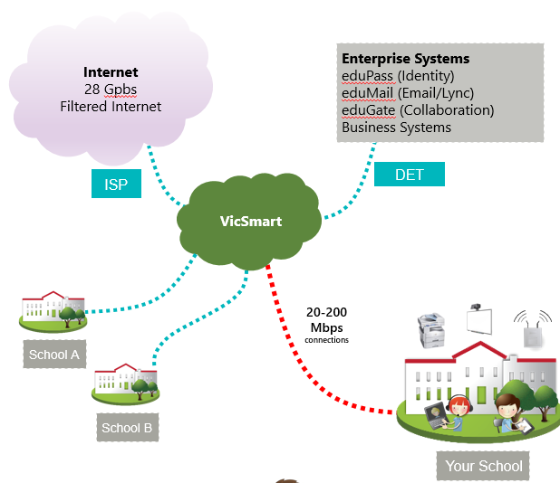

( All Victorian school need to connect back to VicSmart WAN network) ( Not need to worry about this part of the project)

**Filtering**  (Schools are required to have in place)

The Department provides schools with filtered access to the internet through the eduSTAR.ISP delivered by iiNet.

The filtering provided by iiNet uses enterprise products to categorise websites, and block access to potentially unsafe categories.

Internet filtering at the ISP level:

◼ Provides safe and filtered access to the internet for staff / students.

◼ Best of breed filtering technology – provided by iiNet.  
◼ Should be supported by appropriate supervision.  
◼ Can sometimes block legitimate sites (false-positives).

Example of an eduSTAR.ISP filtering setup

( All Victoria school need to have this implemented in their IT)

**EduProxy – Proxy Server**

Edu Proxy provides caching, content acceleration, reporting, monitoring services, and quota management for users, performance testing functionality and more, accessible through a dashboard GUI. Use by Victorian Government school

Internet cache (proxy):

* **Basic filtering** (basic black/whitelist) – block access to problematic websites or resources
* **Shaping** – restrict throughput of web resources known to consume excessive bandwidth, e.g. software updates
* **Reporting & logging** – see top domains, IP addresses & users, download log files if needed
* **Performance monitoring** – view page load times, ping response times & performance of each school relative to state-wide average
* **Caching** – speed up delivery of software updates & compatible web content
* **NetFlow reporting** – view non-web consumption of devices on the LAN, useful to detect & control excessive consumption

Various eduProxy caching tools, such as cache interception, speed access and reduce overall bandwidth consumption.

Cache interception uses a combination of URL detection and content inspection to cache dynamic, streaming or large content locally. Well-known examples include YouTube streaming videos, and Apple software updates.

eduProxy includes monitoring tools to help gauge system performance, including a historical record of service events. The current status of each service check is uploaded centrally, allowing central support staff to identify issues with your eduProxy host, and monitor overall platform/WAN health.

The dashboard is the main screen displayed immediately after logging in to eduProxy. Its primary role is to communicate high-level consumption trends and status information.

Quota control works by counting per-user browsing activity, and blocking access when allocation is exhausted. This feature requires an authentication mechanism to be enabled.

**Standard Operating Environment (SOE) – Device Images**

The Department provides a range of software products pre-installed onto the eduSTAR Standard Operating Environment (SOE) images for both curriculum and administration devices.

Using the eduSTAR SOE images provide students and staff with access to some of the latest educational software. Schools can also add their own additional software to devices running the SOE images as they wish.

eduSTAR curriculum software images:

* Pre-installed on NTP and devices purchased from the Department’s panel of authorised suppliers
* eduSTAR supply an image for schools to customise for students.

Does this mean BYOD would not be compatible with the system, or could the supplied image be installed on a VDI??

* Developed in conjunction with the Digital Learning Branch.
* Contains educational software titles including the Microsoft Office Suite.
* Can modified the SOE to students requirements.

**Software for Colleges**

The Victorian government provides Colleges teachers and students with comprehensive, up-to-date digital tools and software to support the implementation of the Victorian Curriculum, VET and VCE and the achievement of Education State targets. Provision of these software licenses will reduce additional costs to schools and families with access to software including students Bring Your Own Devices (BYOD).

Staff and students can use the eduSTAR catalogue to:

◼ Download software titles for PC, Mac or iPad.  
◼ Order recommended ICT products for school and home use from Department authorised suppliers.

◼ Access self-help solutions, online ICT resources, security and cyber safety advice.

**Online Collaborative Learning Environments**

Schools can provide students and staff with access to **Google Apps for Education** and **Microsoft Office 365** online services at no cost through the Department. This provides schools with access to contemporary digital classroom tools and support for BYOD through services that can be accessed on Windows, Apple, Android and ChromeBooks.

Office 365 includes: Outlook for students, OneDrive, Office, Powerpoint, OneNote, Excel, Teams, Forms and Sway.

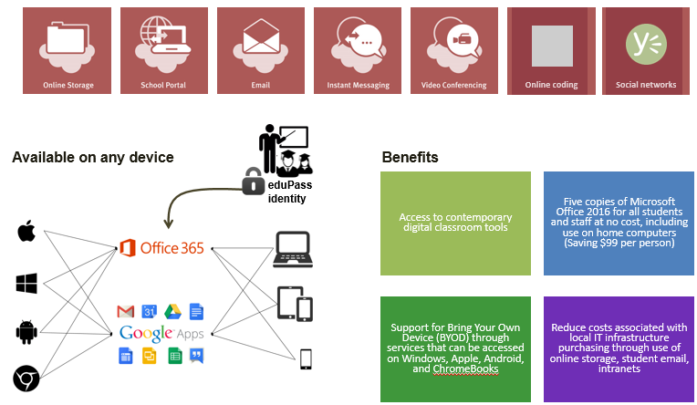

Google Apps includes: Gmail for students, Drive, Google suite (docs/sheets/slides/calendar), Google classroom, Forms and Hangouts.

Available for all teachers in Victorian government schools

**Side by side comparison**



* Exchange (Unlimited storage)
* SharePoint
* Microsoft Teams
* OneDrive for Business (1Tb storage)
* Office Online and apps for up to 5 devices
* Skype
* Yammer

**eduSTAR collaboration tools**

**Webex**

**Google G-Suite**

* Gmail (Unlimited storage) / Calendar
* Google sites
* Google Drive (Unlimited storage)
* Google Docs and apps for unlimited devices (limited offline capability)
* Google Classroom
* Installed in all Victorian Government Schools, available to all DET Staff
* Best of breed Videoconferencing
* Offering a range of devices and software
* Webex teams collaboration tool
* Webex meetings collaboration tool
* Fully supported, available on a range of platforms **Microsoft Skype for Business**

• Instant messaging and desktop video conferencing for staff **Microsoft Teams**

• Collaboration tool available within DET provided Office 365

( All Victoria School have Google 365 application in the cloud)

Clearly the schools are given a lot of useful software licencing by the government, so costs will be dramatically decreased when implementing education software

**IT equipment currently College**

Currently there are 3 physical Servers in the communication room running all sort of application as ADDS, email server, database DHCP,DNS. All about 6 to 7 years old. At the moment it has Windows Server 2012 on one of the Server.

Out-dated design. Server virtualization is a must for the current system

At the moment the server specification are as follows:

CPU: Intel Xeon E3-1270v3

RAM: 32GB RAM

Hard Drive: 500GB Solid State Drive

1GBps network connection with 10TB of bandwidth.

The College has a Veeam software to back up their data for the school. It is stored offline in the event that they need to restore the system if something goes wrong. Some backup information is kept on College grounds any only access by IT manager.

Backup devices and an intelligent uninterruptible power supply (UPS) are installed in the communication room.

Currently the personal information of Students and their reports are back up on a NAS Synology RS129+8 bay mounted rack bay which is located in the server room . It has10 hard drives each consists of 10TB each of total 100TB storage. Currently 80% of the hard drives a full. This hardware device is about 3 years old.

Projecting student population increase more than 20% in future years. Needs an upgrade to match the expectation.

The school IT infrastructure has 10 Cisco 2901 in the a rack which supports secure Data, voice, video application Services and PoE and other applications.

As well about 20 cisco 2960 switches within the school each have 24 ports on each switch. The switches are about 10 years old and run at 100 Mb/s and have two 1GBs uplinks on the switch.

The switches are configured with 4 VLANs which one VLANs for the students one for staff one for administrator and management and the other for Wireless communication for BYOD ( Bring your own devices) to the school.

It has one Cisco AS5506-X firewall has standard features such IP filter, URL, DNS threat intelligence as well blocking an tracking analysis.

It has three 3560 Catalyst Switch 24 port for wireless application

It has Ten Cisco Aironet 1260 services Access point ( to cover the school grounds)

It has one Cisco wireless 5508 LAN controller

These devices are use if students and staff like to connect their laptops or BYOD to the school Wireless network.

The currently the status of cabling within the school is running Cat 5E cable. (Might want to recommend upgrade)

**Telephony Services Legacy Voice Systems**

Historically, schools deployed legacy PBX for telephony systems. As some of these systems are no longer fit for purpose, schools should assess their voice communication needs and the benefits that Voice over IP (VoIP) could provide.

Just more costs, however future proofing is necessary

**Telstra IP Telephony (TIPT)**

Telstra IP Telephony is a new service offering a simple, flexible and scalable voice solution, underpinned by the reliability and security of Telstra’s network.

* Telstra Managed VOIP Service
* A telephony system based on TPAMs costing model
* Utilizes your VicSmart service rather than a separate link
* Requires no onsite Telephony system equipment
* Fully supported by a 24x7 Telstra Service Desk
* Billed directly to your School

**Other Voice over IP (VoIP) solutions**

IP telephony refers to technology that transmits voice communications over a network using IP standards. This includes hardware and software products such as call processing agents, IP phones (both wired and wireless), voice messaging systems, video devices, and many special applications.

Unified communications for schools provides the tools and resources needed to help build an IP based communication systems for advanced voice services with IP telephony, paging (PA), voicemail, applications for broadcast messaging and parental notification and more.

Unified communications integrates many communications technologies:

◼ IP telephony

◼ Video telephony enables real-time video communications using the same IP network and call processing server

Collaboration, presence, rich-media conferencing: enhance the virtual classroom environment with an

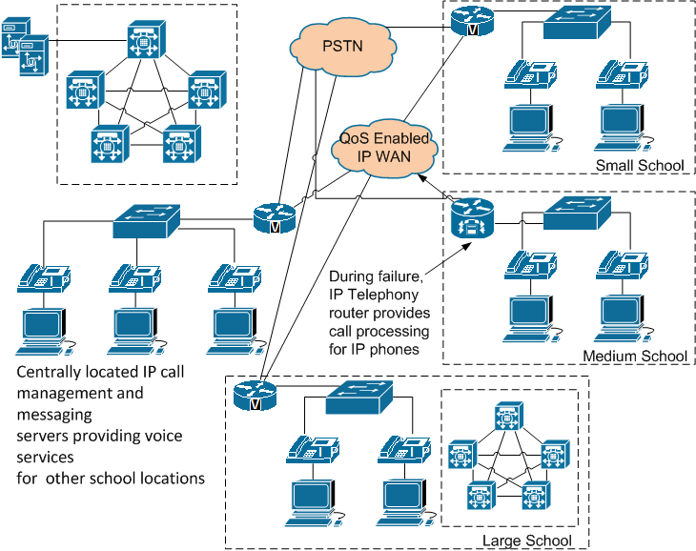

**Example only not in the College**

The school has old PSTN telephone system there are about 30 phones within the school.

As well the school has PA system to talk student the day message required to deliver to the students while they are on school campus.

**Computers in the class room**

Currently there are 10 rooms which have about 25 computers in each room plus a teacher computer as the teacher can plug their laptop to the data projector if they wish. The room is organized so the computers are located round the room next to the walls and windows in the room. There are chairs in the middle of the room. As well each room has a data projected mounted on the ceiling so that teacher can so class note videos etc. As well there are about 50 computers are in the library that students can use and the rest in administrator building and some are in other classrooms. All the rooms do have access to the internet and as well to WI-FI.

Students can bring their own computers to the class room.

All computers BIOS are password protected only can be login by system administrator only.

All computers and laptops will have a standard image with the necessary software for student to use during the year. If any additional software that student require can bring the laptop to the IT services and they can install it. As well any software are required on the school computers they can be pushed out remotely. All computer are reimaged before third term begins.

Students getting additional software installed by taking it to the IT services is not efficient and wouldn’t be functional if another pandemic occurs. Virtualized applications and/or a VDI should account for this problem, allowing students to install all necessary software for learning from the school directly. Virtualized applications would be able to be installed by students if necessary, and run on an instance of the application’s required OS, while a VDI would allow the student to login to a virtual desktop and access the necessary application on its associated OS from their personal device as long as they retain any sort of internet connection

A VDI would be sensible, as the work done at school on the physical desktops would be replicated in a logical fashion when they access the virtual desktop from outside the school later.

**User accounts Administration**

Teachers should have separate authorities from students when accessing computer information. On the other hand, administrators of a school network like Teaching and Learning School Network have special privilege over other users in order to perform system administration and network management. No student is allowed to install software on computers but have administrator rights to their own devices. If student borrow a laptop from school they also should be excluded from install software on those devices.

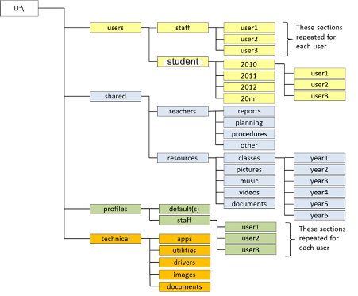

**Example of might how a folder structure and share for staff and students looks like**

Students password are valid for two terms of the year and students need to change their password in term three when they come back from holidays. Notification will be sent to them via school email or SMS on their phones.

You should advise students and staff to choose passwords containing a considerable number of characters, such as eight characters with a combination of alphabetic, numbers and special characters.

**Email Spam**

An email spam refers to bulk, unsolicited emails sending to many recipients who do not want to receive them, such as advertisement. An email spam also increases network loading and thus wastes network bandwidth. The Schools has in place email spam filtering gateway to filter all spam emails from the Internet. Latest spamming lists / blacklists should be regularly updated. Audit logs should be kept at the email spam filtering gateway for future reference. In addition, the following security countermeasures that are in place to prevent spam email:

* Prevent email address harvesting from web sites
* Stop third-party mail relay and open web proxy
* Block by public and private DNS blacklists
* Allow emails by whitelists
* Filter by sender email address, email subject or email content, or use heuristic content filtering
* Block any .EXE, .VBS,. COM, PFI, CMD, and BAT attachments

**Firewalls**

Currently a Firewalls is in place between the school network and the Internet. The school has a physical ( Hardware) firewall setup up . We may want to consider two types of firewalls; firstly with a firewall to the external world called a border or perimeter firewall. There may also be consideration given to having internal firewalls, where we are protecting various enterprise servers from the internal users. These could assist in reducing or preventing internal data theft or hacking into the school system. In some environments the greatest threat is from inside the company network. We need to lock down all ports, and then open any desired ports as needed that is connect to the school. The firewall would then block any unwanted traffic from the outside. As well we have a VPN access to remote users,(teachers) in an effort to protect school data. An enterprise Intrusion Detection System (IDS), or an Intrusion Prevention System (IPS) are also in place with the network to provide defence-in-depth security for their data networks.

**Assessment**

This project will be conducted individually and students are required to come up with their own solution for the school. There is no right or wrong answer to this project. You have been brought as an IT consultant to come with several solutions to the needs of the College and expansion of the use of IT within the College to make it a better experience for students and staff members. If we do have another pandemic the College will be ready.

Your job is to come up with ideas and solution which part of the IT infrastructure of the school that will virtualized. You can use any IT technology you can use ESXI, Hyper-V, Citrix etc.

You need to redesign the school IT infrastructure not complete but part of it. You need to create a demo which part of the IT that you will virtualized or create a video of that you will be proposing . It does NOT need to be complete for demonstration purposes.

With virtualization there are different types: it is up to you which you virtualize for the school:

The different types of virtualization are as follows:

1. **Desktop virtualisation**
2. **Application Virtualisation**
3. **Server virtualisation**
4. **Storage virtualisation**
5. **Network Virtualisation**

You need to choose at **least three types** of virtualization and explain why you have chosen them. If you want you can choose all. However, only need to choose **THREE ONLY. You can answer these questions on this documentation and submit this with your final report.**

**Tasks A. Basic Questions ( 15 marks)**

**Answer these questions on this documentation and submitted with the final report**

* 1. What are the purpose of Virtualization and What are the Pro and Cons of virtualization?

( 3 Marks)

Virtualisation at its core is used to reduce the need for hardware and the costs that come with it. Virtualization can be used to run desktops, applications, servers, storage devices, or networks without the need for the multiple units of hardware that they would otherwise demand.

**Pros:**

* 1. Virtualisation helps businesses with limited funding, as it can eliminate the need to invest in a lot of hardware. Servers require much less maintenance, so ongoing administration and management can be greatly reduced by automating operations, leading to lowered management costs.
  2. businesses usually get overburdened with managing data environments. These environments may contain multiple servers, which only ever utilize around “2 to 10 percent of the server hardware resources”. With virtualization, businesses are able to get the most out of their hardware investments, greatly reducing the complexity by offering resource management capabilities to help increase the efficiency of these virtual environments.
  3. Virtualisation allows for multiple operating systems to be ran in tandem, removing the need for separate physical machines to be installed. A good enough system is capable of hosting both servers and guest machines at once.

**Cons:**

* + 1. The initial cost of implementing Virtualization can be rather steep. Software licenses and servers will usually be upwards of $14,000; however these costs are continuously decreasing as virtualization technology improves.
    2. Not all hardware and software can be virtualized, so plans for system implementations may be rather restrictive, and/or suffer unexpected changes during implementation.
    3. Many virtualization systems are built around each machine working together cohesively. Like cogs in a machine, in many cases if one virtualised component of a system fails, many or even all other components are prone to failing at the same time. For example if a virtualised desktop were to save a file, it would need a valid ISP connection, LAN or Wi-Fi connection, and an online storage option would need to be available. If any aspect fail, the file won’t save.
  1. What are the difference between using ESXI and Hyper-V. What are pros and con of each? ( 3 Marks)

Each solution scales in their own way and is better than the other is some way. While the memory management is different, they both offer dynamic memory management and can run workloads with static memory. The storage on both is done with virtual hard disks, however ESXi stores data inside the virtual machine’s disk, while hyper-v opts for the external hard disk format. They both support snapshot technology, or checkpoints for hyper-v. Of course, hyper-v, being made by Microsoft, is more focused on windows 10 support, however is capable of supporting Linux. ESXi on the other hand is much broader, and is compatible with Windows, Unix, MacOS, and more. They both offer advanced security features, with ESXi utilizing coding and encryption, while Hyper-v can be managed through its active directory, utilizing Windows Defender. Both the Virtualization tools incorporate management tools. For Hyper-v its free software like PowerShell, or Windows Admin Center. For ESXi on the other hand, its standard is vCenter, which comes at a cost. Without this tool however, users will not have access too important advanced features like vCenter Fault Tolerance, Resource Scheduler, and more. These features are not available for hyper-v at all.

**ESXi:**

**Pros:**

1. Deploys virtual systems very well
2. Excellent scalability
3. Utilizes underlying hardware effectively

**Cons:**

1. Pricing and licensing can prove to be expensive
2. Great learning curve for novices
3. Integration with other products can be complex

**Hyper-V:**

**Pros:**

1. Low costs
2. Very flexible system
3. Easy to learn while remaining very functional

**Cons:**

1. All machines can be negatively affected by device resource overloads
2. Automatic load balancing isn’t perfect
3. Not great outside of a windows OS
4. Surveying performance and health of systems can prove to be challenging
   1. Which part of the school infrastructure that you will be virtualise and why? Remember you need to choose three. (3x3=9marks )
5. **Server Virtualization**

The current server setup within the school environment is both outdated and oversaturated, with three six to seven year old physical servers running at once. Two of those severs are running a multitude of tasks, while the other is running an old version of Windows Server, driving up costs and management needed for an ineffective system.

I propose that a complete virtualization of the server system within the school is a logical solution. For the scale of the school being so large (upwards of 1500 students with more to come in the future), virtualizing the server setup and switching to a Virtual Desktop Infrastructure (VDI) will be worth the hefty upfront investment in the long run. This will require the already in place servers to be linked using vSphere, creating a High Availability Cluster and allowing that cluster to run a set of 8 EXSi hosts, hosting their own sets of VMs for students to connect to and run applications through their own devices.

The 8 hosts will be readily available to run up to 256 student/staff accessible VMs. With High Availability, the processing power of the server cluster can be dynamically assigned to the hosts, spreading the necessary power to the hosts as their VMs power on/off. It also allows VMs on failed/crashed hosts to reboot on different hosts, transferring the processing power of the crashed host to the new one, accommodating for all the moved VMs.

1. **Desktop Virtualization**

Although more costly than application virtualization, virtualizing desktops (along with servers) to create a VDI will prove to be very beneficial to the level of maintenance and management required by IT staff at the school.

There are many benefits to virtualizing desktops within an education environment, and even more with the context of this school. With the Victorian government providing a vast surplus of education software to both teachers and students on their eduSTAR image, along with the capability for it to be upgraded, having a pool of VMs available to run this image allows for students to access their work as if they were working on a school system, from anywhere, on any system. This works wonderfully with the schools BYOD system that is already in place. On top of this, the provided eduSTAR image is modifiable, meaning all the necessary software that student will want to access can be added to it, then accessed through the virtual desktop from student devices at any time.

1. **Storage Virtualization**

Since desktop virtualization will be in place, there is no need for network virtualization, as all students working physically outside the school will be able to connect to a virtual desktop, which being on the schools network, will have both the firewall and the eduProxy server applied, keeping user security even while working from home.

Storage Virtualization however will work very well with the newly implemented VDI, allowing students to work on a virtual machine from anywhere, on any device, and save their files to the schools virtual storage system, which will essentially be a pool of all the storage disks located on the physical servers, accessible by the VMs on the ESXi hosts. This means that the files saved by users are accessible from any VM, making student files always available when they log onto the virtual desktop, even if they don’t log on to the exact VM that they saved their files from (which they most likely won’t).

This will also assist with storing student personal data, as the student population is projected to increase above the current physical storage capacity in the future.

**Task B Virtualisation ( 15 marks)**

From Task A Part C. You having chosen three parts of the school IT physical infrastructure that you are going virtualized. Now you have to come up with a design that incorporate the physical infrastructure with the virtualised infrastructure how it going to work. You need to create a small demo or video what are technically detail that you need to consider.

You need to produce a physical topology diagram of your infrastructure how it going look like. For both solutions.

You need to so some research on this. Are you going to use ESXI or Hyper-V or combination of both. This will be your decision (video) explain it.

|  |  |  |
| --- | --- | --- |
| **Student need to complete in this section** | **Yes** | **No** |
| Video ( demo) small part of the Virtualization that you are going to implement in the school. | 5marks | 0 marks |
| Which three Virtualization that student will be implementing for the school and why and discuss in the interview online? | 3 marks | 0 marks |
| One to one video conference with the teacher to discuss their design? ( online) | 4 marks | 0 marks |
| Did the student produce a Physical topology in this project for both solutions as indicated? | 3 marks | 0 marks |
| Total Marks | 15 marks |  |

**Task C Implementation Cost and Duration ( 40 marks)**

In part C you need have to collect what type of Hardware that you need to get for the school for their upgrade of their IT infrastructure. You need to work out what hardware you are going to recommend for the school ? Be objective about this it’s a school and think what it needs to function as learning environment for the students for the teachers and for the community.

That type of computers that you will get the school and why you have chosen those computers, you need to get costing. It can be combination or desktop and laptops I will leave that up to you. What type routers will you get and why how many and why? The type of switches and why? The type of access point for wireless and how many you will get and why.

What type of Servers will you get and why?

What operating system will you use on the computer and laptop?

What type of firewall do you get and why?

There are other thinks that I have not mention but I want you to think about that you need to buy or consider for the school. This part is getting you thinking because you need to what happens in real work of IT.

Any IT you need to add time frame on when things are need to be completed. As well you might need to consider contingency plan. Remember not all project go to plan things can go wrong during the projects due to unforeseen circumstances.

|  |  |  |
| --- | --- | --- |
| **Equipment and costing of the project spreadsheet ( All new equipment might require )** | **YES** | **NO** |
| Number of physical server required and costing? (brand name )  Brief description the equipment specification | 3mark | 0 mark |
| Number of routers required and costing? ( brand name )  Why you have chosen these devices? Give out specification as well | 3 mark | 0 mark |
| Number of switches required and costing? ( brand name)  Why you have chosen these devices and specification as well | 3 mark | 0 mark |
| Number of access wireless access point required and costing? ( brand name) Give out specification and why chosen these devices | 3 mark | 0 mark |
| Number of Wireless controller required and costing? ( brand name) | 3 mark | 0 mark |
| Number of firewall required and costing? ( brand)  Give out specification and why you have chosen these product | 3 mark | 0 mark |
| Number of physical computers/laptops or iPad or tables required and costing? ( brand or non-brand)  The school will need computers are you going to buy or lease? Give reason why? | 3 mark | 0 mark |
| What operating system will be implemented on the computers and laptops? | 3 mark | 0 mark |
| What type of storage device will be implement for the school how much storage required and cost ? ( brand name)  Give out specification of storage why you have chosen it? | 3 mark | 0 mark |
| What type of UPS are you putting in and cost?  Why have you chosen this product and why? | 3mark | 0 mark |
| What virtualization software that will be implemented and the cost of the software? Why you have chosen it? | 3 mark | 0 mark |
| Additional cost of software that may be need but not approved by Victorian government? Need to consider. | 3 mark | 0 mark |
| What are you charging per hour for the project? Per hour. | 1 mark | 0 mark |
| What is the estimated length of time that is project is going to take to complete this project Need to explain as well when things are going to done. Put is spreadsheet time frame but more explanation in final report. | 3 mark | 0 mark |
| **Should be in a spreadsheet break down numbers of devices and costs. You required two versions of costing. In any IT you supply two options. The preferred option and alternative options to the client.** | **40 marks** | **0 marks** |

**Task D Final report ( 15 marks)**

You need to write a Final report on this project. This need to be technically report spelling out what are you going to propose for the school and what are your solutions?

In the final report you should propose two solutions for the client ( to the college board)?

The main body of the project detail the proposed, what part you going virtualised and why and what equipment that the school requires to obtain as well estimated costing of the equipment and any cost of licensing that the college need to obtain that might be supported by the education department.

The cost of all the equipment that will be required for the new IT project.

The time frame when this will be completed includes stages when things to be done.

What is the total cost of the overall project?

What students need to include in Task D ( Marking Guide) Report

|  |  |  |
| --- | --- | --- |
| **Student need to put in their report** | **Yes** | **No** |
| Did the student produce a front cover sheet with name and name of the their company? Also have a table of contents? | 2 mark | 0 mark |
| Did the student produce a summary of the school IT infrastructure? | 2 mark | 0 mark |
| Did the student produce what virtualization are they are going to implement for the school and what equipment there are going to use such as software and hardware? | 3 mark | 0 mark |
| Did produce a spread sheet of the new equipment there are going get for the school and how many and costing of the device? ( from you spread sheet from Task C) | 2 marks | 0 marks |
| Did the students produce any additional cost of software that might need that is not being support by the government? As well any additional equipment you might proposed to implement. | 1 mark | 0 mark |
| Did students produce a new topology layout of the school that they will use? | 2 mark | 0 mark |
| Did students produce the total cost of the project in the report? ( might want to include as an IT consultant to the project what would you charge per hour to do this project?) | 1 mark | 0 mark |
| Biography URL links to all the information you have obtain for this project. | 1 mark | 0 mark |
| Did the report have two solutions for the client?  ( spreadsheet better option) | 1 mark | 0 mark |
| **Total for this section** | 15marks |  |